BLAMO! Travel Toiletry Case

From the amazing

Project Team 4!

User Manual

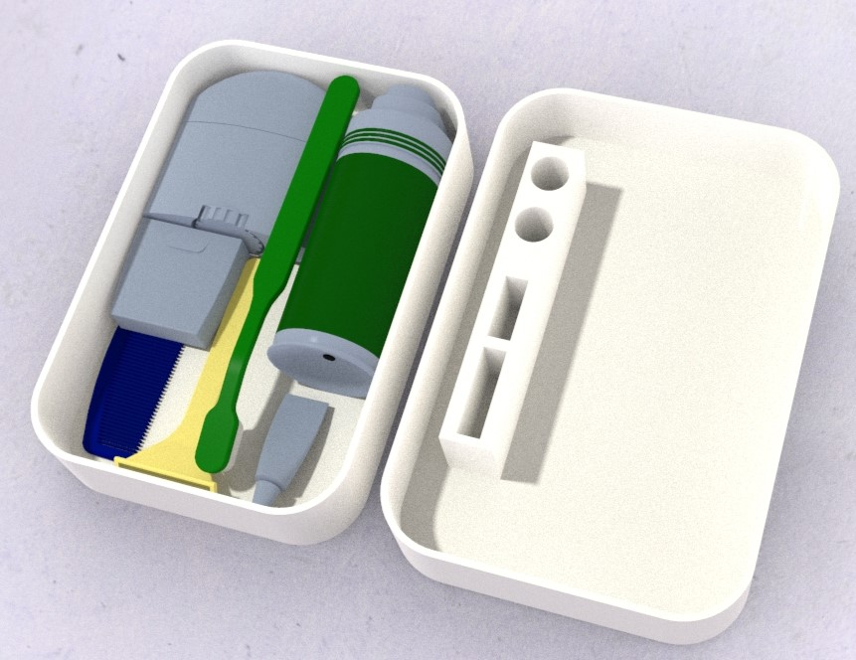

Please review the following manual carefully before operating BLAMO!

Table of Contents

Assembly………………………………………………………………………………………………………………………..3

Initial Setup and Use……………………………………………………………………………………………………….4

Maintenance…………………………………………………………………………………………………………………..5

Warranty………………………………………………………………………………………………………………………..5

Service Center Location & Phone……………………………………………………………………………………..5

Assembly

The BLAMO! Travel Toiletry Case comes pre-assembled and has been designed by experienced, and talented, engineers to meet all your travel needs. To see how the BLAMO! Toiletry Case should look fresh out of the box please refer to the graphic below. The case consists of a bottom tray and top cover-tray with molded slots for your toiletry items.

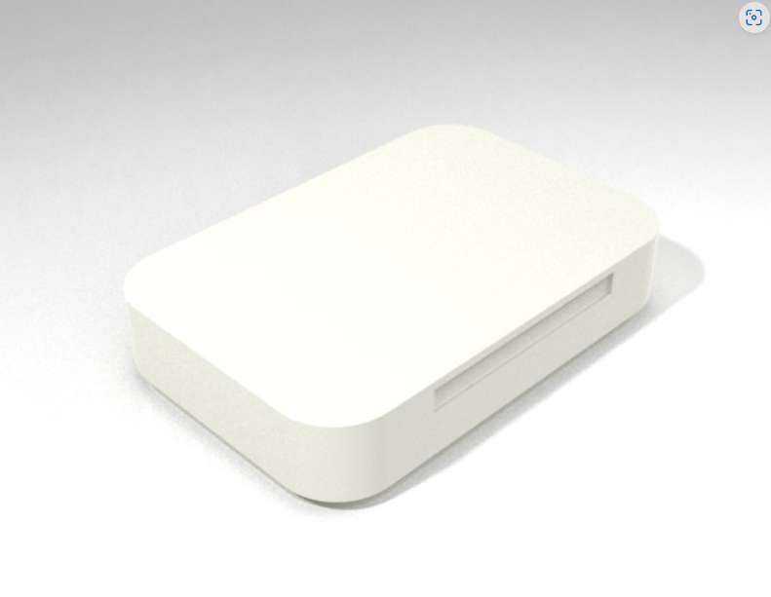

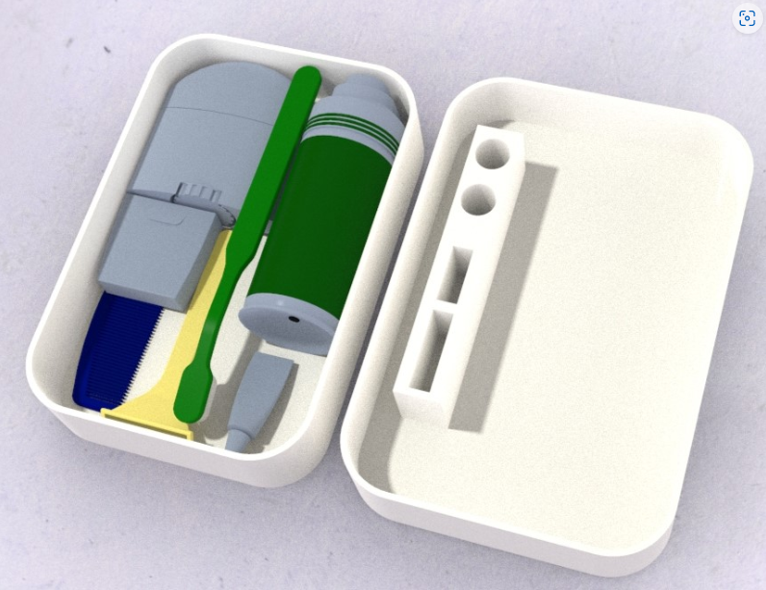

Initial Setup and Use

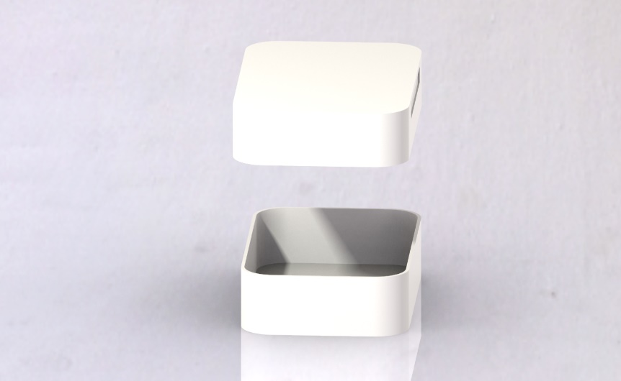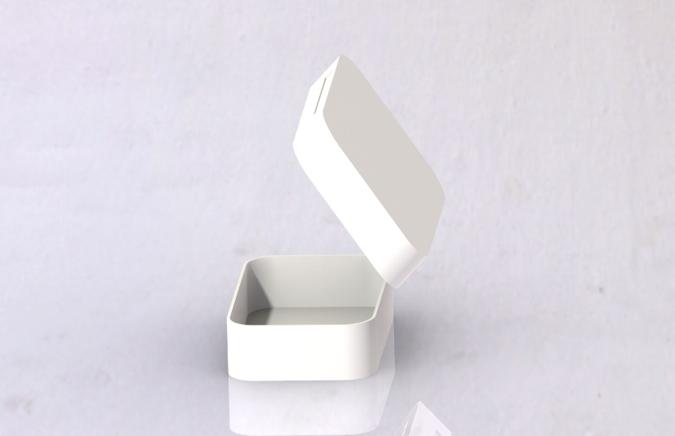The BLAMO! Travel Toiletry Case comes pre-assembled. To open your BLAMO! Toiletry case simply pull the top cover from the bottom tray. To close the case, simply replace the top-tray over the bottom tray and gently push together. The precise tolerances of the case make it easy to open and close while creating a watertight seal to protect your luggage.

2

1

1. Slide top-tray up and off from the bottom tray.
2. Remove top-tray and place where desired.

The case’s lid comes with slots designed to hold your toiletries items up from any contaminated surfaces. To see an example of this please refer to the figure below.

Care and Maintenance

The BLAMO! Toiletry Case requires very little maintenance besides that it should be cleaned periodically for sanitary purposes. Our product was designed to handle all sorts of cleaning methods, including dishwashers, however we recommend cleaning with mild soap and warm water once a month or as needed.

Warranty Information

Our number one priority is to make sure that our customers are satisfied with their purchase. For this reason, BLAMO! offers a 30-day moneyback guarantee. If you are not content with your purchase, please visit the “Meet the BLAMO! Team” page on our website and send us an email to receive your money back.

Service Center Location & Phone

For all questions, comments, or concerns please contact:

Larry Pinto

[lpinto@uncc.edu](mailto:lpinto@uncc.edu)

Saul Castro

[Scastro7@uncc.edu](mailto:Scastro7@uncc.edu)

Service Center:

Website: <https://webpages.charlotte.edu/lpinto/ENGR_1202_final_project.html>

Address: 426 N Tryon St Charlotte, NC, 28202

Phone: (203) 913-1307